South Australian Yarn Ups 8- 14 April 2015

Adelaide
Our South Australian Yarn Ups kicked off in Adelaide where we met with the good folks of the Register of Aboriginal Veterans of South Australian (RAVSA) who provided us with some great insights to the many Aboriginal South Australians who served. We were also lucky enough to catch up with the inspirational Marjorie Tripp, who was the first Aboriginal woman to join the Navy.

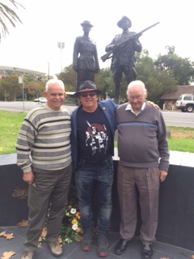
(L to R) Register of Aboriginal Veterans of South Australia members Frank Lampard and Uncle Lewis O’Brien with Professor John Maynard at the Torres Parade Aboriginal Memorial.

Port Lincoln
At Port Lincoln on the Eyre Peninsula we met with Vietnam Veteran Les Kropinyeri and his wife Robyn, who talked to us about his experience in the service and their involvement in the setting up of the Aboriginal and Torres Strait Islander War Memorial at the Torrens Parade Ground in Adelaide.
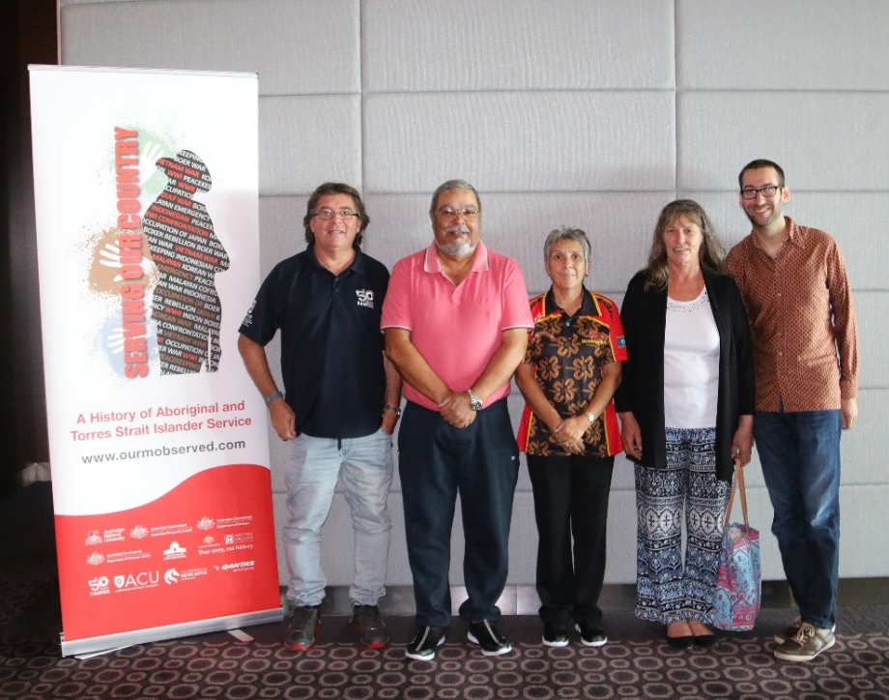
(L to R) Professor John Maynard, Les & Robyn Kropinyeri, Sheree Honner and Dr. Noah Riseman at Port Lincoln

Raukkan
Raukkan Community was our next stop. This place has a very proud and rich history of service. They believe that at least 100 men from here served in Defiance from WW1 to Vietnam. Their passion for their people that served is so strong they raised funds to erect a War Memorial to honor those that served. It is a place that the community can go to every ANAZC day to remember them.
We also heard incredible uplifting stories of the whole community forming a guard of honour along the streets, singing for their men as they marched off to war. The sense of pride within this small community is very clear and humbling.
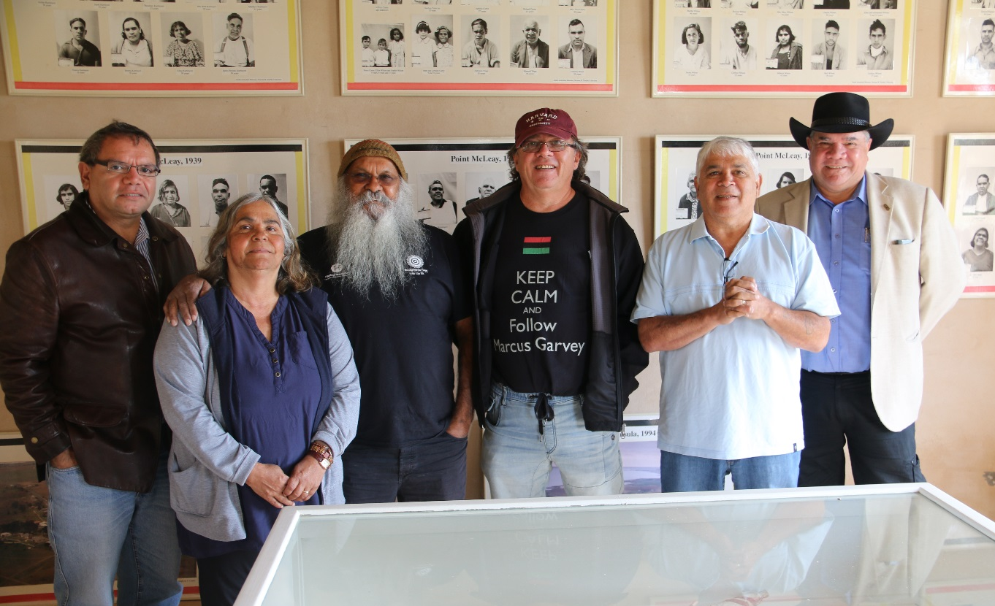
(L to R) John Pearson, Verna Koolmatrie, Major Sumner, Professor John Maynard, Clyde Rigney and Professor Mick Dodson at Raukkan Community.
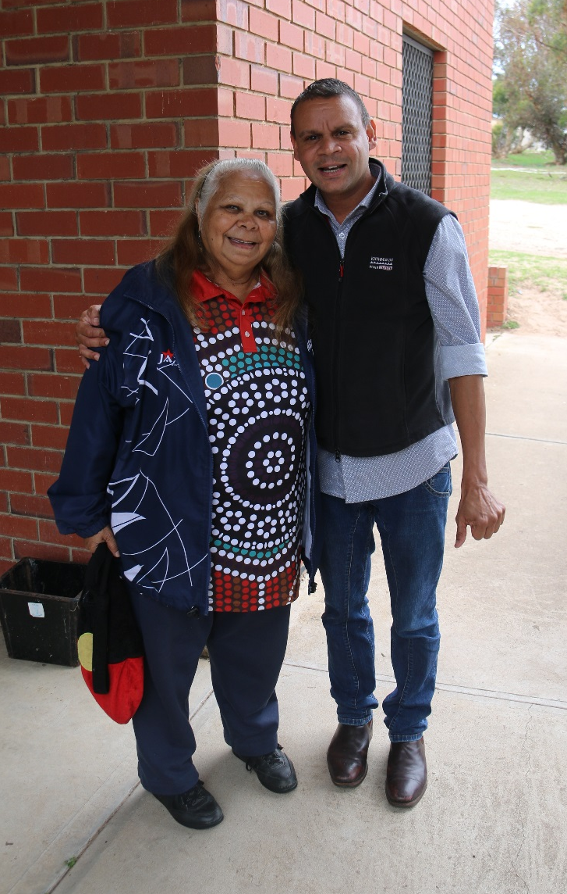
Aunty Dot Shaw, who came and shared her families stories, here with Community Consultation Co-ordinator, Craig Greene.

